**ODATA**

**T-CODE: SEGW**

**T-code: /N/IWFND/MAINT_SERVICE**

**What is OData in SAP?**

OData is an Open Data Protocol used in web technologies.

OData is used by SAP to make SAP data accessible to other platforms so that the non-SAP users can also access this data to develop web applications, websites, mobile apps, etc.

**OData is used to create RESTful APIs.**

OData is first introduced by Microsoft now it is being used for web applications, mobile applications etc.

OData fetches the data from one or many databases and tables with the help of **select, insert, delete, or modify** statements.

It is based on the HTTP framework.

In other words, in the application layer, we have an internal table, and that internal table data is passed out through **OData to HTTP**.

In a single HTTP request, you can get both the data and metadata,

or table structure and you can also do CRUD-Q operations which mean that you can Create the data on the database, Request the data, Update the data, Delete the data or you can perform various Queries operations on the database over the internet.

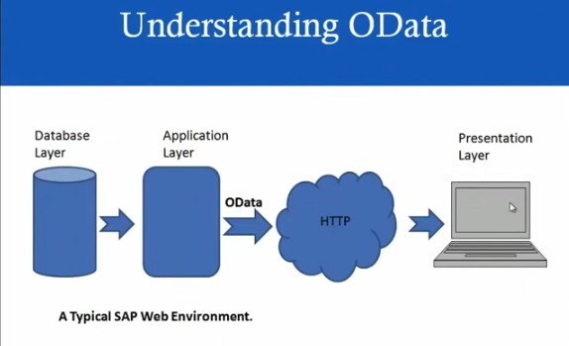

## What is REST?

REST means Representational State Transfer. It is a kind of software architecture for the World Wide Web.

## What is the need for OData service in SAP?

OData service is used in the SAP gateway to connect with non-SAP platforms.

**There are three types of OData services.**

1. **OData ABAP services -**> For ODATA ABAP services the backend server is SAP ECC/CRM/SRM.
2. **OData HANA services** -> For ODATA HANA services the backend server is SAP HANA.
3. **OData External services**-> For OData External services the backend server is non-SAP servers /External servers.

## What are the uses of OData services?

The job of ODATA services is to fetch data from the database and table to OData services through SQL Statements,

And from ODATA services the data is displayed on the front-end application screen like SAP UI5 or FIORI screen in the form of some screen elements like Tables, Graphs, Dropdowns, Radio buttons Checkboxes etc.

The front-end services like SAP UI5 or FIORI screen will be the same for all ODATA services whether it is ODATA services for ABAP or HANA or External services.

## What is SAP NetWeaver Gateway?

SAP NetWeaver Gateway is a technology that offers connectivity to SAP applications using any programming language or model without the need for SAP knowledge by using REST services and OData protocols.

## Step by Step procedure to create OData services:

**Step1:**Goto T.Code**SEGW**.

**Step2:** On the **SAP Gateway Service Builder**screen press the Create Icon.

**Step3:**In the **SAP Gateway Service Builder** screen a pop window for **Create Project** appears fill all the required information as shown below:

**Project:**z_odata  
  
**Description:**OData service for testing  
   
Select the packages or **Local Object** and press the tick button.

Now the new **Project Z_ODATA**created. Press the **Save** button.

**Step4:**In the **SAP Gateway Service Builder**screen expand Z_ODATA project node which we created.  
Select **Data Model**node. Right click-> **Import**->**DDIC Structure**

**Give a suitable name for Entity type:**

In the **Create an Entity Type or Complex Type** tab type the name of the Entity.  
  
**Name:** Airlines

In the **Import from ABAP Structure**tab select the ABAP structure.

**ABAP Structure:** VBAK

And press **Next**button.

Check the required fields and press the **Next**button.

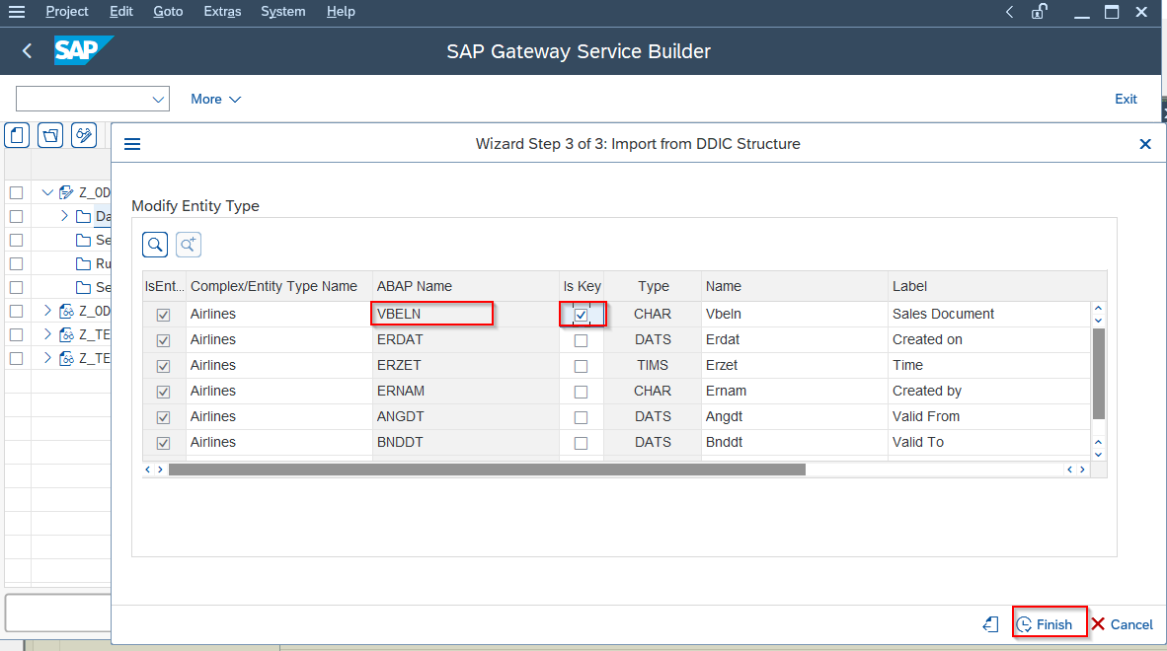

Select **VBLEN**asakey field in the table and pressthe**Finish** button.

Click the “**Generate**” button.  
  
Then **Model Provider Class**and**Data Provider Class** will be generated automatically by the system.

Press the Tick button.

**Step5:**Go to Transaction code**/N/IWFND/MAINT_SERVICE**

**Step6:**Click on **Add Service**button.

**Step7:**On the **Add Selected Services** screen fill in the required information.

**System Alias:**LOCAL

**Technical Service Name:** Z_ODATA_SRV

**External Service Name:** Z_ODATA_SRV

And press the **Get Services**button.

**Step8:**In the **Add Selected Services** screen check the service and press the **Add Selected Services** button.

**Step9:**Now the **Add Services** screen comes, select the package or just use the **Local object**and press the **tick**button.

An Information message will be shown where it will confirm about the service is created and metadata loaded successfully

**Step10:** In the **Activate and Maintain Services** Screen press **SAP Gateway Client**button.

**Step12**: In the **SAP Gateway Client** press the **Execute** button.

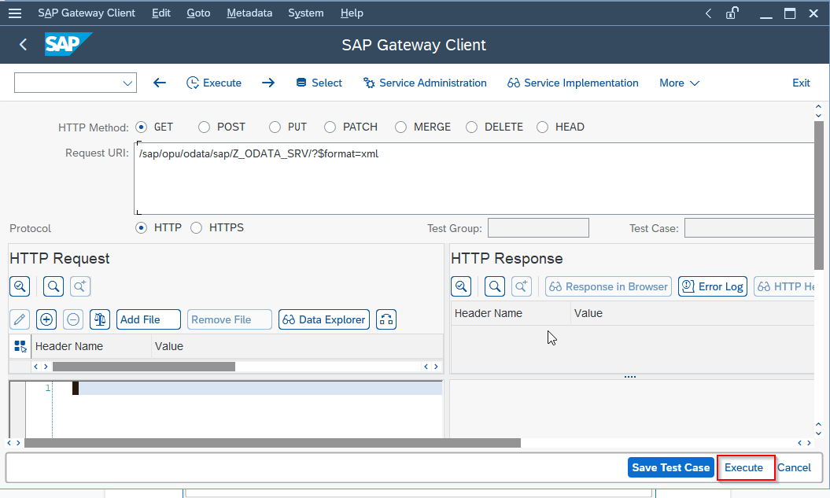

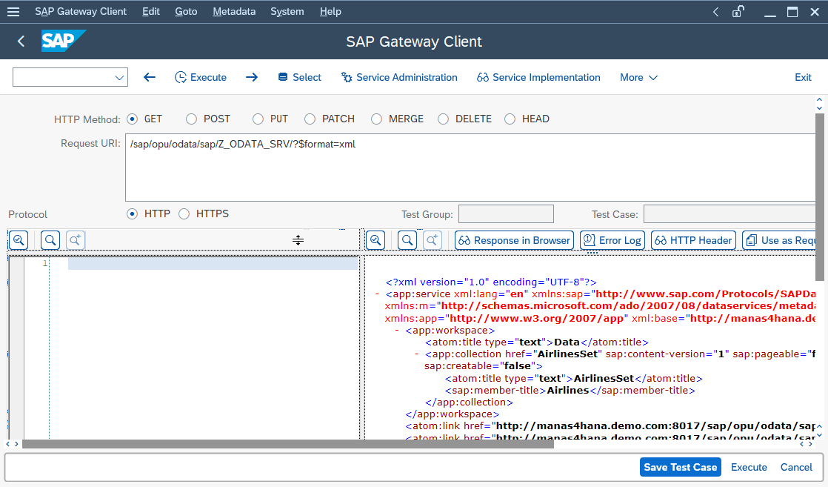

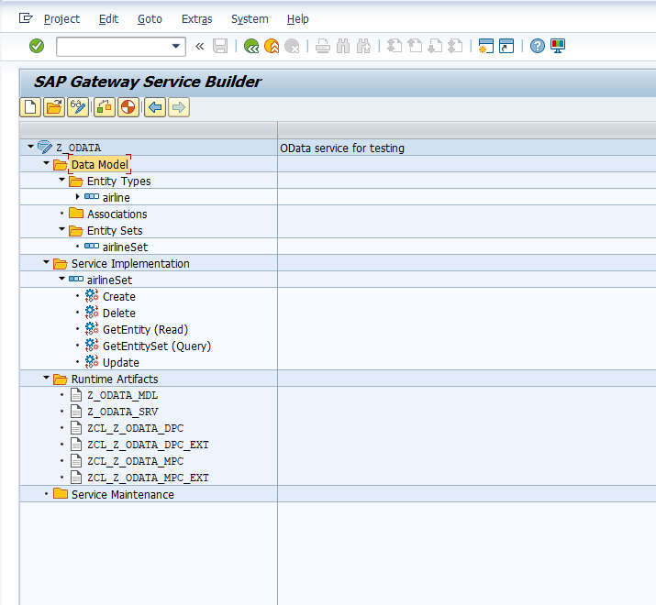

**Operations in ODATA**

In this section, we will explore all the methods generated automatically once you generate an OData. In last article, we have already instructed to write all your CRUD operations related code in DPC_EXT class. Hence, we will follow the same concept here.

SAP ABAP OData provides different methods for CRUD operations, these are:

|  |  |  |
| --- | --- | --- |
| Method | SQL Operation | Description |
| GET_ENTITY | Select | This method is used to read a single data based on table keys |
| GET_ENTITYSET | Select | This method is used to read entire data of a table |
| CREATE_ENTITY | Insert | This method is used to create/insert a new data in table |
| UPDATE_ENTITY | Update/Modify | This method is used to update an existing data in table |
| DELETE_ENTITY | Delete | This method is used to delete an existing data in table |

**Query in SAP OData**

In this section, we will explore all the Query we can perform while reading data from OData.

In above section, we have learnt how to do read calls using GET_ENTITY and GET_ENTITYSET.

Sometimes, we need to filter out data according to our requirement, or to get total number of data counts or to get data in specific order.

These all SAP OData Queries are explained below:  
Here, let us suppose <your service name>  = https://isd.sap.com/<OData Service Name>

|  |  |  |
| --- | --- | --- |
| **Query** | **Description** | **Example** |
| $metadata | It gives the metadata detail of your service. By metadata we mean it will provide information about all the entity sets with their field names and their attributes | <your service name>/$metadata |
| $FILTER | It is mainly used during Read Entity Set call. During Read, we can send some filter value in backend that can be later used in where condition of Select queries | <your service name>/$FILTER |
| $top and $skip | It is mainly used to get limited data in the UI, in case you are reading all the data, and the table is having a very large data | <your service name>/$top and $skip |
| $orderby | This is used to order the data in ascending or descending order for a specific key | <your service name>/$orderby |
| $format=json | This returns the data in form of JSON format. By default, the result is in XML format. | <your service name>/$format=json |
| $inlinecount | This returns the number of data of a table that will appear in the UI | <your service name>/$inlinecount |
| $expand | This is used to bind the association and navigation data together | <your service name>/$expand |
| $value | This is used to return the media data | <your service name>/$value |

In the following steps, I will list down steps to create an entry through OData service. Similar steps are required for other CRUD operations.

To configure a well-defined SAP Gateway OData service, complete the following steps in your SAP system.

These steps cover the general procedure but need some consideration for your own SAP OData system and your preferred techniques for configuring SAP.